
https://atlas.cid.harvard.edu/

Optimal Industry Development Strategy Using Economic and Product Complexity

[Country]

─
The Economic Complexity Lab - Columbia University
Zev McManus-Mendelowitz, Alexandra Garcia, Kelly Mi, Margarita Demkina, Allison Lin, Helena Yang, Jane Zhang, Daniel Xu, Ryo Shibata, Navia Zhang, Haoxian Chen, Davepriyan Gunaratnam, Rohan Macherla, Ajit Akole, Shomik Ghose, Alex Wei-Liang Ku, Sannidhya Modi, Xilin Wang
Optimal Industry Development Strategy for [Country]

0. Executive Summary

In this report, we analyze the economic trajectory of [Country] over the period from [Start Year] to [End Year], examining its production capability and structural evolution through the lenses of Gross Domestic Product (GDP) and Economic Complexity Index (ECI). We find that [Country] demonstrated a [GDP growth quality] level of economic growth, with an average annual GDP growth rate of [GDP growth rate] during this period, placing it [Relative GDP growth quality] its [Category] peers.

{One to two sentences of country-specific context: key export sectors, investment trends, or structural factors that drove or constrained growth during [Start Year]–[End Year]. Example context: major FDI inflows, commodity price exposure, policy reforms, or external demand shocks that shaped the trajectory.}

On the complexity front, [Country]'s ECI [increased/decreased] over the analysis period, reflecting a standing [ECI peer standing] among the comparable [Category] economies examined. {One sentence on whether this ECI trajectory aligned with the GDP trend and what the divergence or alignment implies about the depth of [Country]'s productive diversification.}

Examining realized industry development between [Start Year] and [End Year], we find that [Country] [Industry development] across the majority of its industry groups: [POS RID END] groups moved closer to global competitiveness thresholds while [NEG RID END] retreated, a [RID progress direction] from [POS RID START] improving groups at the start of the period. Based on our opportunity gain and sensitivity analysis, the industries offering the greatest complexity upside for [Country] are [Industry 1], [Industry 2], and [Industry 3]. Sensitivity analysis further identifies [Industry 4] as the sector whose marginal expansion yields the largest positive shift in ECI.

Our Structural Optimality Index (SOI) analysis measures the degree to which [Country]'s realized investment trajectory aligns with the theoretically optimal complexity-based development path. [Country] ranks in the [SOI quartile] quartile globally, with an adjusted R² of [R^2 adj], indicating a [SOI quality] level of structural alignment. In concrete terms, [Country] has [SOI mismatch quality] channeled resources toward [Overinvested] — sectors where the complexity opportunity is more limited — while underinvesting in [Underinvested], which offer greater complexity upside. Given the positive correlation between SOI and long-run GDP growth established across our global sample, [Country]'s [Overall quality] structural alignment is consistent with its [GDP growth quality] growth record, and suggests that measurable gains remain available through a more complexity-guided development strategy.

1. Report Overview

In this report, we analyze the economic trajectory of [Country] during the period from [Start Year] to [End Year]. {One sentence providing relevant context about what made this period significant for [Country] — e.g., a notable economic transition, regional trade shift, or major policy change — without assuming a specific global event.} Specifically, we examine [Country]'s macroeconomic trajectory through the lens of Gross Domestic Product (GDP) and Economic Complexity Index (ECI), which reflect a country's production capability and productive structure, respectively. We then analyze the industrial framework and structural changes of [Country] based on quantitative measures including the Product Complexity Index (PCI), followed by a detailed analysis of how those changes aligned with optimal development strategies as measured by opportunity gains at the industry level. We conclude with macro-level results derived from regression models established on a global scale, which take into account countries' positions in the product space.

2. Macroeconomic Results

2.1 GDP Ranking and Changes
Figure 1 illustrates the GDP time series for [Country] and its peer economies ([Peer 1], [Peer 2], and [Peer 3]) from [Start Year] to [End Year]. [Country] demonstrated a [GDP growth quality] average annual GDP growth rate of [GDP growth rate] over this period, placing it [Relative GDP growth quality] peers among the compared economies. For reference, the average annual growth rates of the peer economies were: [Peer 1] at [GDP rate peer 1], [Peer 2] at [GDP rate peer 2], and [Peer 3] at [GDP rate peer 3].

{One to two sentences noting any particularly striking patterns in the GDP trajectories: convergence or divergence in absolute GDP levels between specific countries, any year of sharp contraction or acceleration visible in the chart, or a notable crossing of GDP levels between [Country] and one of its peers.}

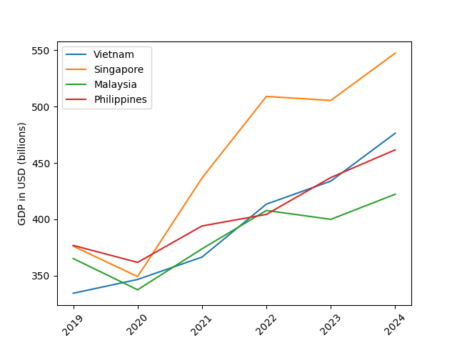
Figure 1. GDP Comparison Among Peer Countries ([Start Year]-[End Year])

2.2 ECI Ranking and Changes

The Economic Complexity Index (ECI), introduced by Hausmann and Hidalgo (2009) to quantify the knowledge embedded in a country's productive structure, is illustrated in Figure 2.

[Country]'s ECI [increased/decreased] from [ECI start] in [Start Year] to [ECI end] in [End Year], a change of [ECI change] — a [ECI change magnitude] shift in productive complexity. Relative to its [Category] peers, [Country]'s ECI trajectory was [ECI peer standing]. For context, ECI changes over the same period were: [Peer 1] at [ECI change peer 1], [Peer 2] at [ECI change peer 2], and [Peer 3] at [ECI change peer 3].

{One to two sentences explaining what drove the ECI movement — for example, which industry groups expanded or contracted, whether increased export diversification or concentration was the primary driver, or whether the ECI trend reflected a structural shift or was dominated by a single sector.}

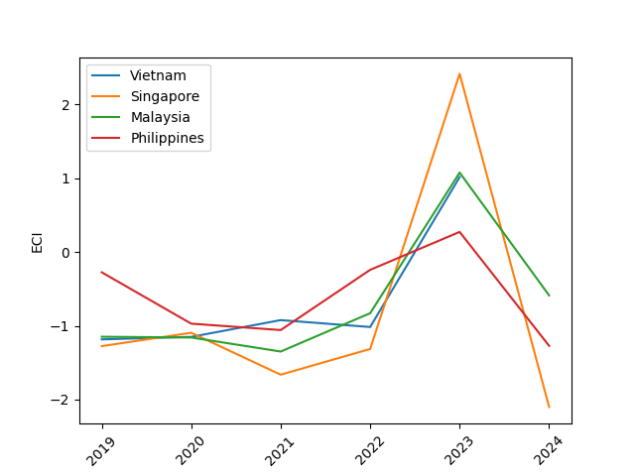
Figure 2. ECI Comparison Among Peer Countries ([Start Year]-[End Year])

Figure 3 provides a combined view of GDP and ECI for [Country] across the full analysis window. The two indicators were [GDP ECI consistency] during this period. {One sentence describing the specific relationship between the GDP and ECI trajectories — for example, whether ECI led or lagged GDP, whether they moved in tandem or diverged in particular years, and what this implies about [Country]'s structural development.}

{Optional — include only if an external shock materially disrupted [Country]'s GDP or trade structure during [Start Year]–[End Year]: identify the shock (conflict, sanctions, commodity price collapse, natural disaster, or similar), the approximate year(s) affected, and whether the ECI trajectory absorbed or reflected that disruption. Omit entirely if no such shock is relevant.}
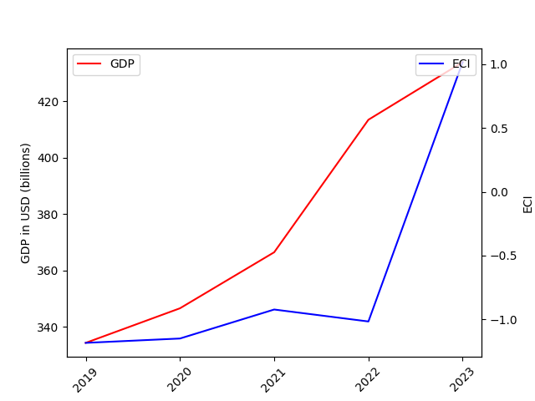
Figure 3. GDP Growth and ECI for [Country] ([Start Year]-[End Year])
3. Production Analysis

3.1 Product Categorization
Our main data source in this research is the UN Comtrade Website (https://comtrade.un.org), which provides us with valuable information on countries’ export values on an annual basis, including highly specific export data for more than 5000 categories of products. In order to have a holistic vision of the product space of a country, however, a level of categorization is required. Products in our data source are labeled from 010000-999999, with the first two digits representing a general category to which the product belongs. Based on the 99 categories extracted from the label, we further group the products into the 18 most widely-accepted industries, as summarized in Table 1.

Note that the High-complexity Products industry group is not a distinct industry but rather an aggregated industry that encompasses the most complicated products from the most technologically-advanced industries (as measured by PCI). This industry serves as an indicator for us to quantitatively evaluate how well a country has performed in developing cutting-edge technologies and closing its technological gap with advanced economies, which has become a topic of wide concern today. Indeed, when we rank the 18 categories based on PfCI (an equivalent concept of PCI as calculated based on the 18 categorized product groups), the High-complexity Products industry has the highest PfCI among all industry groups.

Category | Description
Animals and By-products | All kinds of meat, livestock and related by-products
Vegetables, Fruits and Plants | All kinds of plants, edible vegetables and fruits
Food and Preparations | Edible preparations, raw cooking materials and appliances
Clothing and Accessories | All kinds of fabrics, filament, clothing and accessories
Textiles | All kinds of textile articles and related products
Wood Products | Book, paper and other elementary products related to wood
Metals | Mining of all sorts of raw Metals
Refined and Processed Stones | Refined or processed stone products such as pearl and ceramics
Energy Drilling and Mining | Mining industry for energy, minerals, stone materials, etc.
Daily Instruments | Basic daily instruments such as sport requisites, timing and measuring tools
Raw Manufacturing | Basic products made from plastic, rubber, leather, etc.
Chemical Manufacturing | Advanced chemical products and pharmaceutical products
Chemicals | Raw chemical materials and by-products
Machinery and Construction | Machinery and mechanical appliances, including electrical equipment
Transportation | Vehicles and locomotives including aircraft, ship, railway, etc.
Weapons | Explosives, arms and ammunition
Services and Utilities | Financial, business, legal, communication, travel Services and Utilities, etc.
High-complexity Products | Agglomeration of advanced products with highest PCIs
Table 1. Categorization of Products

We further observe a positive correlation between the GDP and the export of High-complexity Products. A higher adjusted R-square exists between GDP and High-complexity Products exports, indicating that more successful economics, as measured by GDP, tend to be those that are capable of producing and exporting High-complexity Products as we define them. Tables 2a and 2b show the OLS results in a universe of 107 and 21 typical countries respectively.

 | High-complexity Products | Food and Preparations | Animals and By-products
Adj. R-squared | 0.075 | 0.006 | 0.002
F-statistic | 9.556 | 1.638 | 1.175
No. Observations | 107 | 107 | 107
Table 2a. OLS Regression Results of GDP against Percentage Volume of Exports

 | High-complexity Products | Food and Preparations | Animals and By-products
Adj. R-squared | 0.149 | 0.003 | -0.012
F-statistic | 4.510 | 1.059 | 0.7542
No. Observations | 21 | 21 | 21
Table 2b. OLS Regression Results of GDP against Volume of Percentage Exports

3.2 Realized Industry Development

Based on the aforementioned product categorization, we aim to capture [Country]'s realized industry production strategy between [Start Year] and [End Year] on a complexity level. In Hausmann and Hidalgo (2009), distance is defined to be a measure of how far a country is from a certain product, not in its product space. We extend this concept to all product groups and quantify how technically equipped a country is to develop the corresponding product groups. In other words, the shorter the distance between a country and a product group, the more capable a country is of developing products within that group. Defining this net distance change as the Realized Industry Development (RID), our export data allow us to calculate and compare the RID of [Country] and the 18 product groups in [End Year] and [Comp Year] through the difference, where a positive RID indicates a shortening of the distance (i.e., advancement of the industry), and a negative RID indicates the reverse. It is notable that the number of industries with positive RID experienced a [RID progress direction] from [POS RID START] to [POS RID END] from [Comp Year] to [End Year].

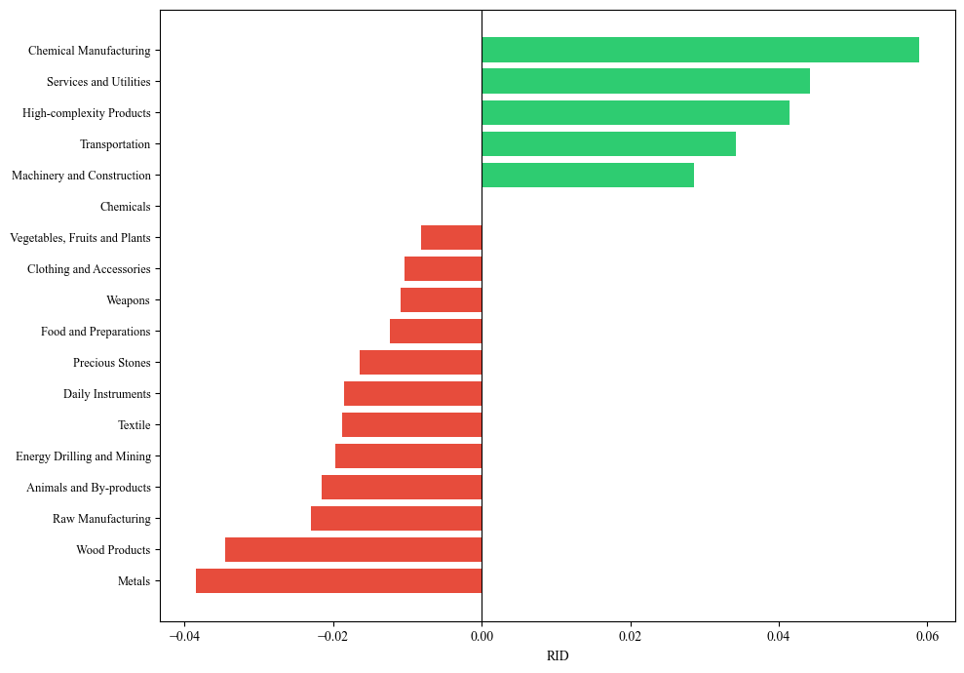
Table 3. Realized Industry Development (RID) of [Country]
3.3 Regional and Global Comparison

Table 4a below summarizes how the production strategy adopted by [Country] compares with selected leading economies in the world across different years, as measured in RID. Leading economies such as [SDV Leading 1], [SDV Leading 2], and [SDV Leading 3] gave a considerable level of attention to more advanced product groups such as {[Product Group 1] and [Product Group 2]} in [End Year] and {[Product Group 3], [Product Group 4], and [Product Group 5]} in [Comp Year].
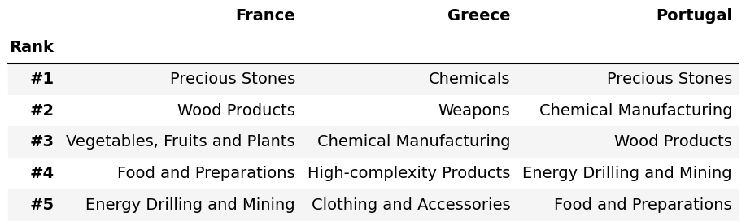
Table 4a. RID Comparison across Leading Economies ([End Year])

Table 4b further examines [Country]'s development strategy against those of emerging economies on a global scale. Reasonably, emerging economies such as [SDV Peer 1], [SDV Peer 2], and [SDV Peer 3] have devoted the majority of their efforts to intermediate industry groups, showing {drastic/moderate/minimal} shifts in strategies over the course of the analysis period.

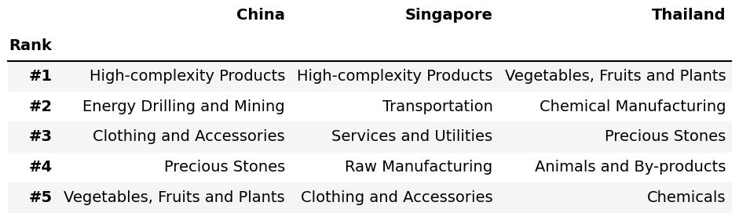Table 4b. RID Comparison across Emerging Economies ([End Year])
4. Product Space Design

4.1 Suggested Development Vector
As outlined above, distance gives us an idea of how far each new product is from a country’s current mix of exports. As defined in Hausmann and Hidalgo (2009), distance is “the weighted proportion of products connected to goods p that country c is not exporting, i.e., MCP = 0.” Based on this definition, the distance between a country and any product that the country is currently exporting (i.e., the country is a significant exporter of the product as compared to the global average) is zero. Similarly, opportunity gain quantifies the contribution of a new product in terms of opening up the doors to more and more complex products. Intuitively, a product that a country is currently exporting (i.e., MCP = 1) has an opportunity gain of zero. An unreasonable investment in a certain product p would lead to a relative decrement in the export of more profitable products and therefore lead to a negative opportunity gain of product p. The opportunity gain is not the only estimator of a country’s level of economic development. However, among countries with comparable economic strength, those having higher ECI, or in other words, more reasonable economic structures are often in better shape.

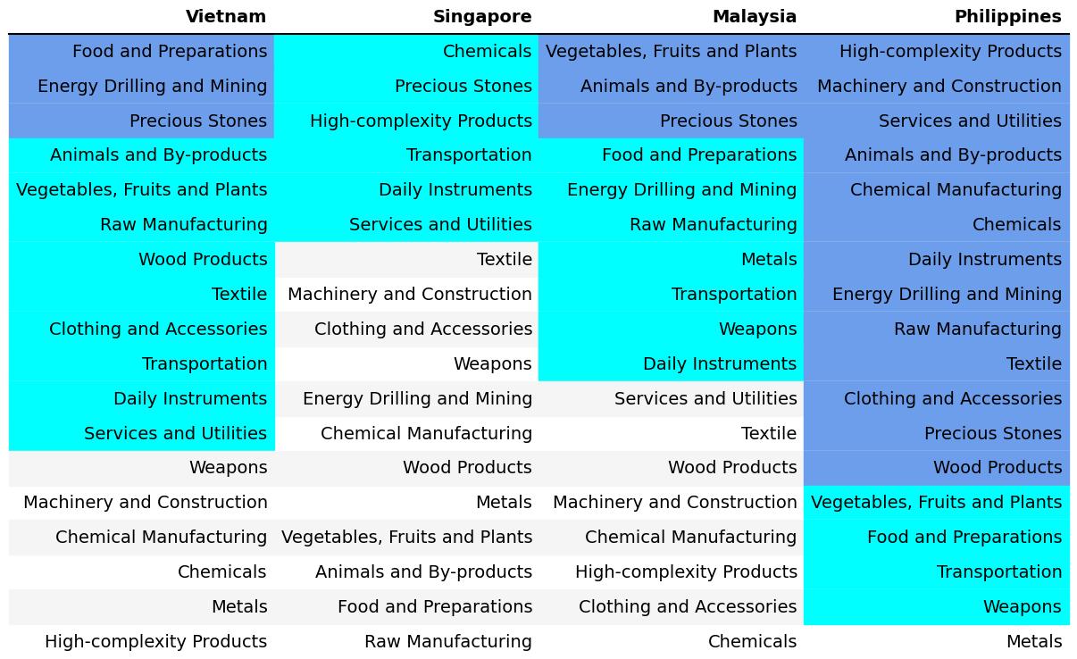
Table 5. Opportunity Gain Ranking on a Comparable Scale ([End Year])

We define the ranking of opportunity gain for a country c, as the Suggested Development Vector (SDV) of c. Table 5 summarizes how the SDV of [Country] compares with a selected group of comparable and leading economies in the world, with the industry groups ranked in decreasing order of significance.

Dark blue indicates positive opportunity gains, light blue indicates zero opportunity gains, and white indicates negative opportunity gains. The result shows that leading countries barely have any industries with positive opportunity gain. In other words, those countries are already in the most stable and efficient economic structure. Without the necessity of economic transition, those countries merely need to maintain a steady and balanced economic development. In contrast, developing countries have nearly half of industries with positive opportunity gain and share common interests in [SDV top 1] and [SDV top 2] industries. It can be concluded that [Country] shares the characteristics of developing countries, with a balanced economic structure that leans towards {descriptor}-level industries.

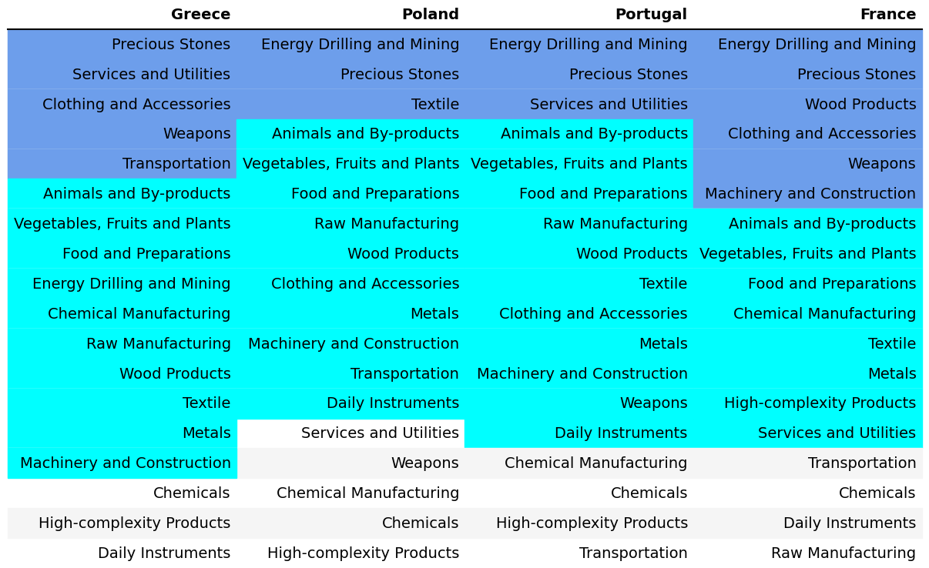
Table 6. SDV of Other Sample Countries ([End Year])

4.2 Budgeted Industry Development Strategy and Interpretation
The optimal budgeted industry development strategy aims to solve the most efficient allocations under the budgeted constraint of different situations of heuristic total export growth. In order to obtain such an allocation portfolio, we formulate an optimization problem as the following:



where k(x) is the second largest eigenvector of $M_{CC'}$ after adding $x$ to the original export vector, C is the country that we are interested in, P is the product space, B is the heuristic budget.

If we can solve this problem, then we can know what the largest ECI to which a country can improve. Accordingly, the optimal solution $x*$ that we obtain here is exactly our optimal allocation. However, the biggest problem is that the objective function is not convex. Therefore, we cannot apply the classical tools for convex optimization to this problem. In order to solve this problem, our idea is to use a greedy algorithm. The way that we apply the greedy algorithm is that firstly we separate the total budget into k equal parts, and then for the first equal part we try to search for the product that can optimize our objective function by iterating through each $p∈P$. After we find the optimal product p for this equal part, we add the amount back to the export value of this product p and update the ECI for this country. If we observe that ECI does not change after iterating all the products, then we can add up one more equal part to invest. Until we find there is an ECI increment, we add the amount now to that product. The equal rest parts can be done in the same way.

By definition, a greedy algorithm is a kind of local search algorithm that is possible to run into a local minimum. Therefore, for local search algorithms, one typical way to keep it away from the local minimum is to enhance the vision of the algorithm by looking more steps forward. In our setting, whenever we obtain an increment of ECI, we mark down the required amount of export growth. Simultaneously, we continue searching for the next ECI increment point, compare the ratios of these two possibilities and pick the largest one. The ratio is defined as the following:

where ${ECI}_{p}$ is just the ECI of the country after adding some amount of export increment to product $p$, which is exactly the amount that is able to make ECI change. Also, we can express it in the way of $||$$x_{p}-x_{0}$${||}_{1}$.

In this way, we can obtain a further sighted greedy algorithm. Also, the number of parts that we would like to separate the budget into also matters. In order to solve this problem, we added a stabilizer on top of the enhanced greedy algorithm by running the algorithm for different numbers of parts and selecting the portfolio with the largest ECI increment and most complex economic structure.

Besides, it is quite common that there is a surplus in the budget. To deal with the surplus, we just add it to the product which needs the least amount of dollars to make $M_{cp}$ = 1 (i.e., the smallest amount of required export increase).

4.3 Economic Panel

As stated above, the enhanced greedy algorithm is developed mainly for solving the optimal allocation strategy. In order to visualize this allocation, an economic panel is created, consisting of a pie chart, a line chart and a table. First, a pie chart is used to show the percentage of each product in the optimal portfolio. The number located in the center of the circle denotes the heuristic growth of total export, which is also our budget. Each category in the chart has a determined percentage of the allocated budget. The lines below the pie charts show how the ECI changes during the searching process of the greedy algorithm. Even though sometimes an increase of the export by 15% or 20% does not seem reasonable to developed countries, yet it can also give a sense of how a country should develop in the long term. Eventually, the graph in the end is just for numerical explanation for the pie charts.

4.5 Interpretation
For the purpose of a clear explanation of the line charts, we label all the products in Table 7. Please refer to this table when trying to understand the investment trajectories in the line charts.

Label | Product Names
1 | Animal and By-products
2 | Vegetables, Fruits and Plants
3 | Food and Preparations
4 | Energy Drilling and Mining
5 | Chemicals
6 | Chemical Manufacturing
7 | Raw Manufacturing
8 | Wood Products
9 | Clothing and Accessories
10 | Textile
11 | Metals
12 | Machinery and Construction
13 | Transportation
14 | Weapons
15 | Daily Instruments
16 | Precious Stones
17 | High-complexity Products
18 | Services and Utilities
Table 7. Products Labeling

Figure 4 shows an economic panel for [Country] in [End Year]. {One to two sentences describing the patterns observed in ECI increments across budget levels — for example, whether ECI gains were concentrated at lower or higher budget thresholds, and whether returns were roughly linear or showed a step-change at a particular level.}

For [End Year], a 5 percent increase in export would emphasize [Top industry 5pct], followed by [Top industry 10pct], [Top industry 15pct], and [Top industry 20pct] for 10, 15, and 20 percent export growth respectively. These strategies go in line with the suggested trajectories based on ECI. {One to two sentences discussing the patterns observed in the investment portfolio across budget levels — for example, whether the same industry dominates across thresholds or whether priorities shift significantly as the budget grows.}
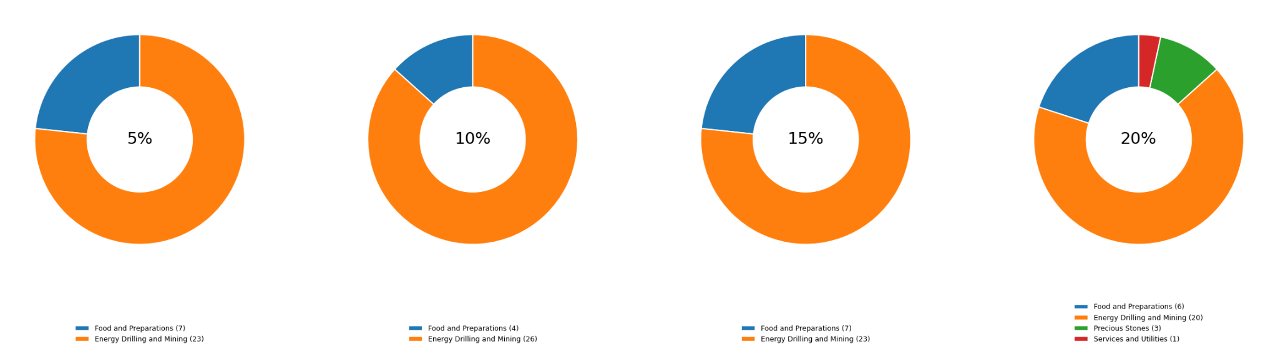
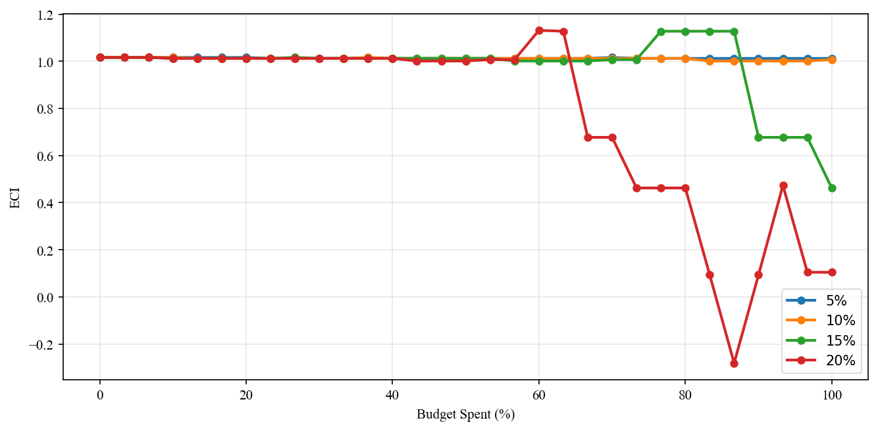
Figure 4. Greedy-Based ECI Improvement Results of [Country] with Different Budgets ([End Year])

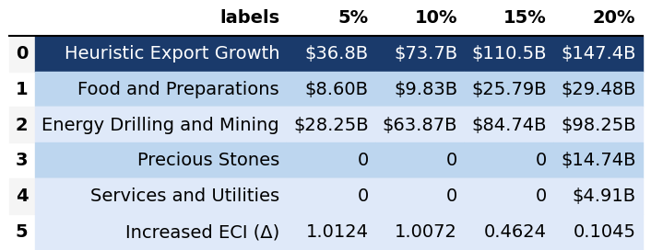
Table 8. Portfolio of [Country] ([End Year])

4.6 Sensitivity Analysis and Contingency Strategy

In the following section, our broad aim is to understand how sensitive [Country] is to changes in export in various industries. While the Economic Complexity Index has been shown to contain valuable information about the economic strength/capacity of a country, little has been said as to the stability of the measure itself. We seek to uncover the main drivers of stability under a country's ECI score and better understand longer-term projections for ECI growth. Additionally, gaining an intuition on the industries that are bolstering an economy and the industries that offer the greatest return per unit of investment is best done through visualization of industry-specific sensitivity. To this end, we have developed two categories of sensitivity analysis.
4.7 ECI Sensitivity Graph
First, in order to assess the effect particular industries have on each respective country, we developed ECI Sensitivity graphs (Figure 5). We use the shocking methodology to increment or decrement an industry’s export level by a certain percentage and recalculate the ECI, all else being equal. While freezing the export dynamics of the rest of the world and enacting an instantaneous shock in export for a particular industry and country may not reflect real-life dynamics, what it does offer us is an understanding of a country’s level of dependency on an industry in the context of ECI. The shocking is done in small percentage increments in order to smooth out the resulting curve. Additionally, a recurring theme one will see is that for most industries, a breaking point occurs where the ECI either jumps upwards or downwards, creating a hockey stick shape rather than a linear trend. While the inflection point may not be accurate in the context of real life, comparing the various inflection points across industries can give us valuable insight.

Figure 5. Sample ECI Sensitivity Graph
The graphs are formulated as follows. The first chart, Incremental ECI Sensitivity, shows positive shocking in which export numbers are shocked upwards per industry. The X-axis is in terms of percentage shock per current dollar value of export. The Y-axis is the recalculated ECI level post-shocking. The second chart, Decremental ECI Sensitivity, follows the same format except the X-axis represents negative shock. In other words, exports for each industry are decremented, and the ECI is accordingly recomputed.

4.8 Sensitivity Analysis Results and Interpretation

We examine [Country]'s ECI Decremental and Incremental Sensitivity Charts for[End Year]. An increase in [Industry 4] will lead to the highest change in ECI,followed by [Industry 5] and [Industry 6]. Under positive shocks, ECI [Pos Trend] with additional investment in [Industry 4], confirming it as the primary lever for complexity growth. For negative shocks, [Neg sens top] emerges as the most impactful industry, while reducing investment in [Industry 4] causes ECI to move [Neg Trend]. The rest of the industries do not appear to have the same level of sensitivity.

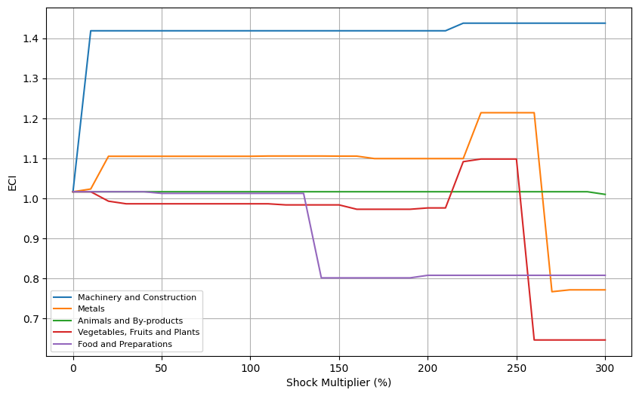
Figure 6a. Incremental ECI Sensitivity for [Country] ([End Year])
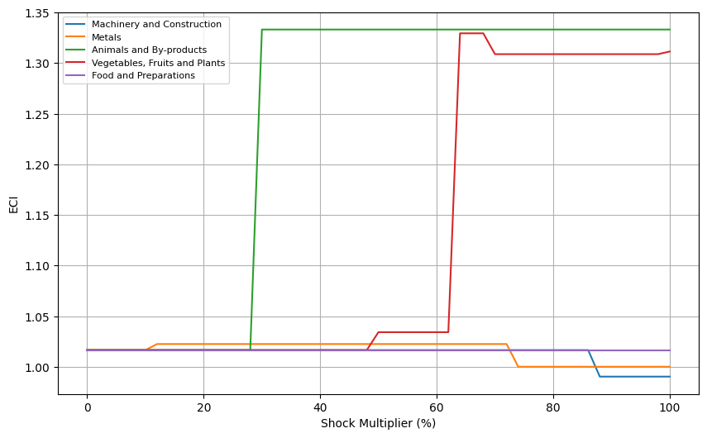
Figure 6b. Decremental ECI Sensitivity for [Country] ([End Year])

5. Macro-level Predictions

5.1 Structural Optimality Index
ECI sensitivity described in the section before has proven to be a significant factor in deciding the economic outcomes of countries. In order to quantitatively evaluate how effective our development strategies are and how deviations from the suggested developmental path will lead to suboptimal growth results, we define the measure – Structural Optimality Index (SOI) – on a country level as the Adjusted R-Square obtained from regressing the country’s realized industry development over the suggested development strategy. Both strategies are quantified in nature, with the realized development represented by increasing export in every major industry group and the suggested development strategy represented by the opportunity gains of developing the corresponding industry groups as calculated in previous sections. The adjusted R-square from the regression thus provides us with a quantified measure of how the development path adopted by the country has fitted with/differed from calculations on a complexity level.

After obtaining this measure for all countries in our database, we further regress countries’ five-year economic growth, which is defined as the percent increase in GDP (USD), over their SOI. Figure 9 illustrates the regression output, which shows a strong positive correlation between countries’ SOI and their five-year GDP growth, achieving an adjusted R² of [R^2 adj]%. In other words, the more a country develops, as suggested by calculations on a complexity level, the better economic outcomes it achieves.

Table 14: OLS Regression Results
Dep. Variable: GDP | F-Statistic: [F-Stat]
R²: [R^2] | Prob (F-Stat): [Prob]
Adj R²: [R^2 adj] | No. Observations: [nobs]

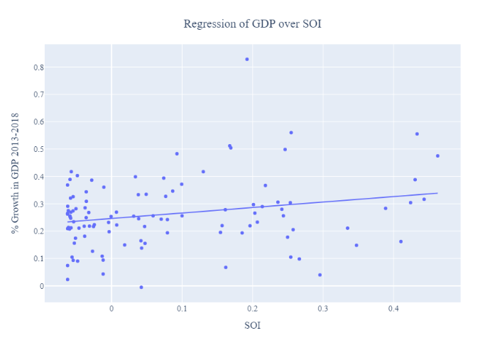
Figure 9. Regression of Five-Year GDP Growth over SOI ([Start Year]-[End Year])

5.2 SOI of [Country] and Its Implications
During the examined period, [Country] has a [SOI quality] level of structural optimality as compared with all countries for which data is available. As the regression in Figure 10 suggests (the red curve represents export increase and the blue curve stands for opportunity gain of the corresponding industry), [Country] demonstrates a [SOI quality] level of correlation with the suggested developmental path, having an adjusted R-square of around [R^2 adj].

[Country] ranks in the [SOI quartile] quartile among all countries in terms of SOI
and recorded an average annual GDP growth rate of [GDP growth rate] from [Start Year] to [End Year], placing it [Relative GDP growth quality] its [Category] peers — consistent with the regression result in Figure 9. {One to two sentences naming a specific contrast economy with a notably different SOI — identifying its SOI quality and GDP growth outcome to illustrate the cross-country pattern.}

Specifically, [Country]'s [GDP growth quality] economic progress from [Start Year] to [End Year] can be at least partially explained by a development strategy that demonstrates a [SOI quality] level of alignment with our suggested developmental path. In particular, [Country] has [SOI mismatch quality] channeled resources toward [Overinvested] — sectors where the complexity opportunity is more limited — while underinvesting in [Underinvested], which offer greater complexity upside.

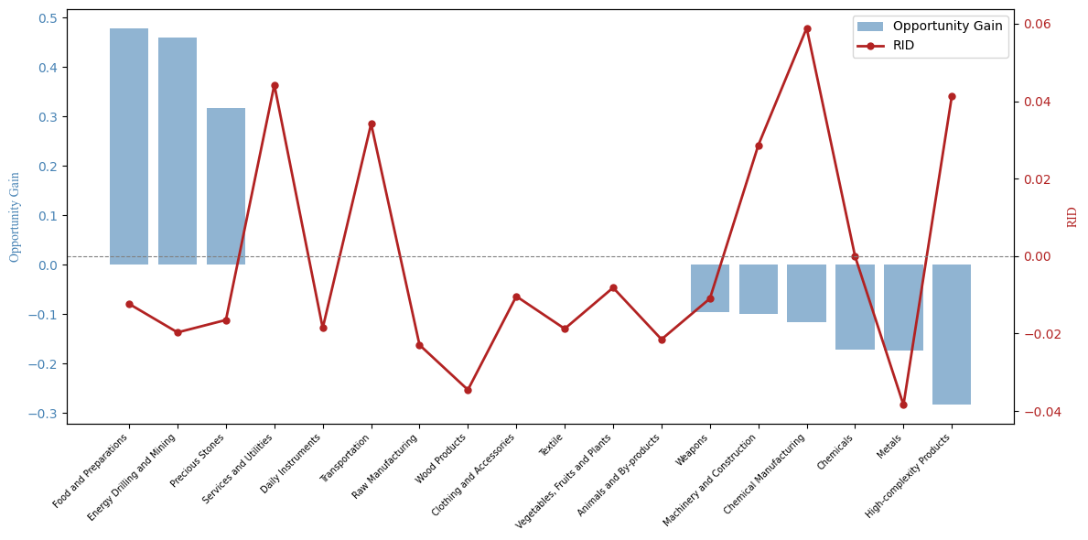
Figure 10. SOI of [Country] ([Start Year]-[End Year])

6. Concluding Remarks

In conclusion, [Country] has demonstrated a [GDP growth quality] level of economic growth in terms of annual GDP increase during the period from [Start Year] to [End Year], concurrent with a [ECI change magnitude] shift in economic complexity as compared with its peer economies. An average annual GDP growth rate of [GDP growth rate] placed [Country] [Relative GDP growth quality] its [Category] peers, and ECI [increased/decreased] by [ECI change] over the same window.

We believe that [Country]'s trajectory can be partially explained through the analysis of the economic and product complexity structure on the industry group level. The product classification system we adopt allows us to measure the realized industry development for various industry groups and to observe that [Country] [Industry development] in developing the majority of its industries during the period, with the count of positively developing industries [RID progress direction ing] from [POS RID START] to [POS RID END] between [Comp Year] and [End Year].

Based on our analysis of opportunity gain and sensitivity across major industry groups, [Country] can further its gains by prioritizing [Industry 1], [Industry 2], and [Industry 3]. Sensitivity analysis further identifies [Industry 4] as the sector whose marginal expansion yields the largest positive shift in ECI. We further note that [Country] has [SOI mismatch quality] channeled resources toward [Overinvested] while underinvesting in [Underinvested], indicating a [SOI quality] level of structural alignment with complexity-guided development, having an adjusted R-square of [R^2 adj]. Since a positive correlation exists between five-year GDP growth and the structural optimality index as we define and calculate, [Country]'s [Overall quality] structural alignment is consistent with its [GDP growth quality] growth record, and suggests that measurable gains remain available through a more complexity-guided development strategy.

References

Hausmann, R., Hidalgo, C., Bustos, S., Coscia, M., Chung, S., Jimenez, J., Simoes, A. and Yıldırım, M. (2007). The Atlas of Economic Complexity. [online] Atlas.cid.harvard.edu. Available at: http://atlas.cid.harvard.edu/.

Balassa, B., “The Purchasing Power Parity Doctrine - A Reapprais- al,” Journal of Political Economy 72, 584-596 (1964).

Feenstra, R.; Lipsey, R.; Deng, H.; Ma, A. & Mo, H. “World Trade Flows: 1962-2000” NBER working paper 11040. National Bureau of Economic Research, Cambridge MA (2005).

United Nations Commodity Trade Statistics Database (http://comtrade.un.org/db/), accessed in August 2019.

The World Economic Forum, “The global competitiveness report,” (various years).

Barro, R. & Lee, J-W. “A New Data Set of Educational Attainment in the World, 1950-2010,” NBER Working Paper No. 1590 (2010).

Kaufmann, D. & Kraay, A. “Governance Indicators: Where Are We, Where Should We Be Going?” Policy Research Working Paper 4370. Washington, DC: World Bank (2008).

Hanushek, E.A. & Woessmann, L. “The Role of Cognitive Skills in Economic Development,” Journal of Economic Literature 46(3), 607- 668 (2008).

